1. WEBSITE SPECIFICATIONS
a. Website Objective
The main objective of the 696 DEPT website is to create a strong online presence and serve as an e-commerce platform for selling streetwear t-shirts.
Business Goals:
-Sell branded streetwear t-shirts directly to customers
-Build a recognizable urban fashion brand identity
-Increase brand awareness locally in Botswana
-Provide a seamless online shopping experience

b. Target Audience
Primary Audience:
People aged 16-30, both mle and female, mainly located in Gaborone and surrounding areas.
Technical Aptitude:
People who are comfortable using smartphones, social media and online shopping platforms.

c. Type of Website
The website will be a E-commerce + Brand Showcase Website showing product listings, About page, Shopping cart & checkout, Contact form as well as images and banners.

2.INFORMATION DESIGN & TAXONOMY
Sitemap

Home (index.html)
│
├── Shop
│ ├── All T-Shirts
│ ├── New Arrivals
│ ├── Best Sellers
│
├── Product Details Page
│
├── About 696 DEPT
│
├── Gallery
│
├── Contact / Feedback
│
└── Cart

Site structure
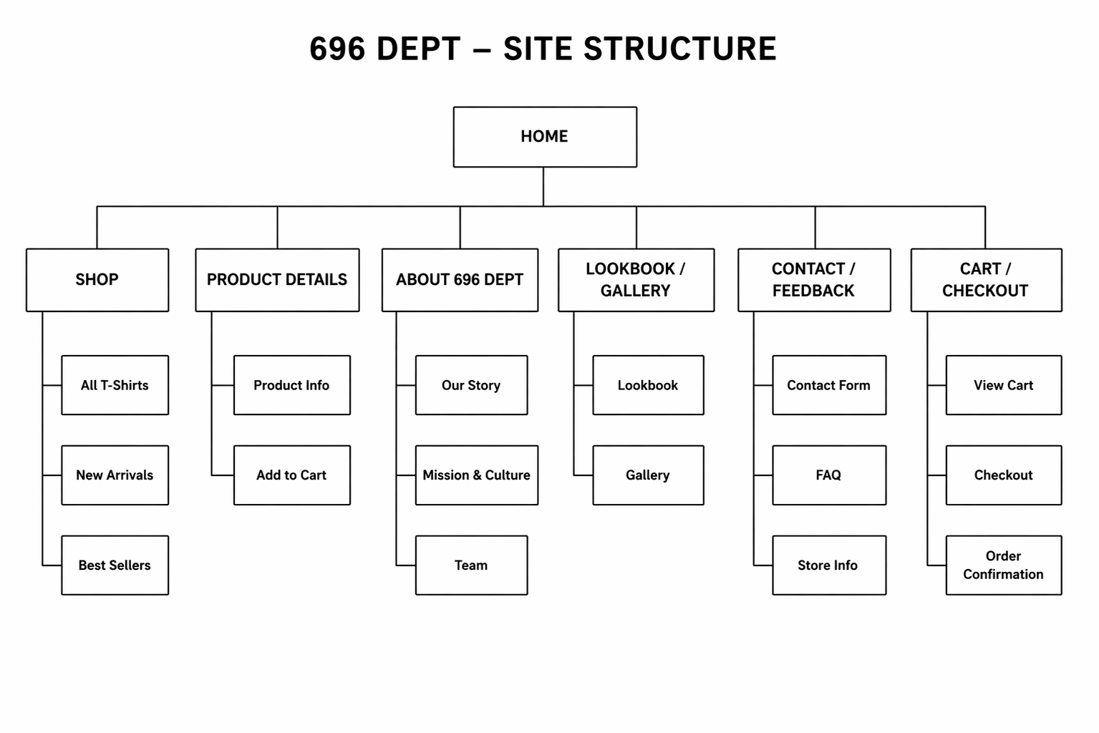

Navigation Flow
- User lands on Home
- Clicks Shop
- Selects a product
- Views product details
- Adds to cart
- Proceeds to checkout

Taxonomy
Main Categories:
Products
Collections
Brand Content
Customer Interaction
Subcategories:
T-Shirts → Graphic / Plain / Limited Edition
Collections → New / Trending / Seasonal
Brand → Story / Mission / Culture

Storyboard
Homepage → Highlights brand + featured products
Shop Page → Displays all items
Product Page → Detailed product view
Cart → Purchase process
Contact Page → User interaction

3. TECHNICAL BRIEF
Technologies used;
HTML5 - Structure of pages
CSS3 - Styling and layout
Bootstrap - Responsive design
JavaScript - Interactivity (cart, buttons)

Development tools;
GitHub - Version control
GitHub Pages – Hosting

Graphic & design tools;
Figma- wireframes

PAGE TEMPLATE DESIGN
